DIGIWALLET JOOMDONATION BUTTON PLUGIN INSTRODUCTION

# Installing

* Step 1: On Admin Page, Select **Extensions\Manage\Install** menu
* Step 2: Browse your extension plugin file to upload and install to your Joomla

# Configuration

After finished installing plugin, you need to configure the plugin before using.

1. Step 1: Enable Digiwallet Button Plugin. This plugin used to show the Donate button on the Article content. On left menu click **System \ Plugins** then active the plugin with name “Digiwallet Donate Button”

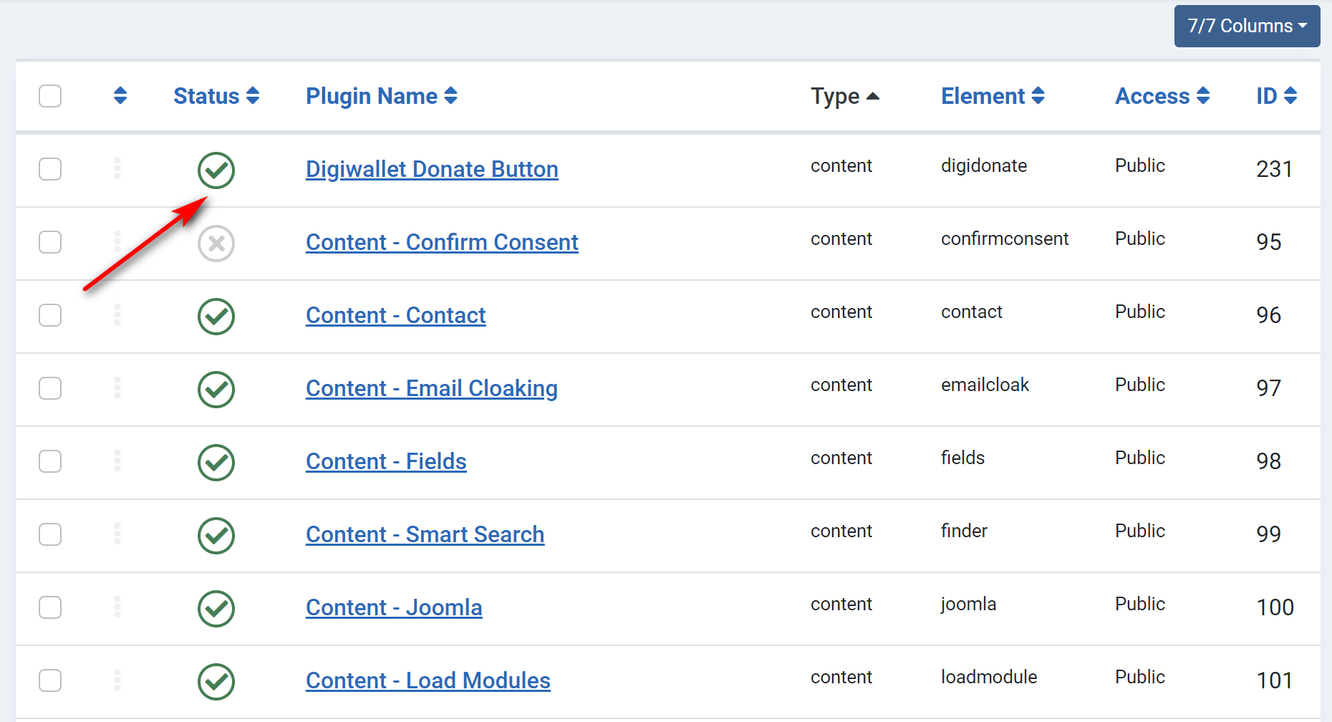

1. Step 2: Configure Digiwallet payment methods: On top menu click **Components \ Digiwallet Donation \ Digiwallet donation configuration** to show configuration screen.

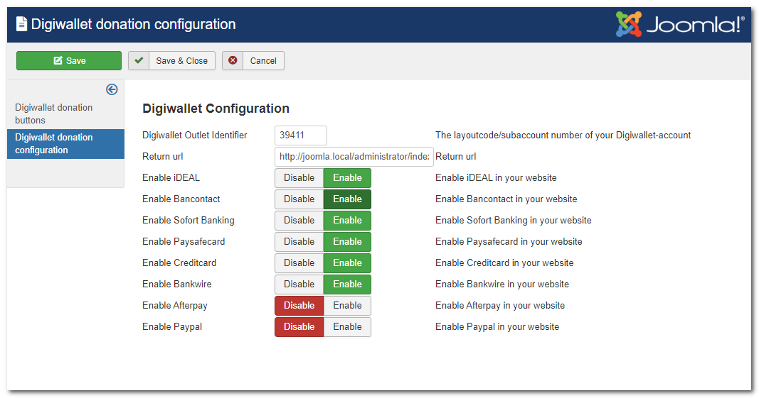

* Digiwallet Outlet Identifier: The layoutcode/subaccount number of your Digiwallet-account.
* Return url: the url that will redirect to after payment success or failed
* Enable iDEAL: on/off payment method iDEAL

1. Step 3: Enable Digiwallet donation module: On top menu, select **Extensions\Module** then select Digiwallet Donation module to change settings. On the setting page, make sure the module is “Published” and the Module Assignment is set to “On All Page”
2. Step 4: Configure Donation buttons: To add one or more link buttons to add to your Articles for paying with Digiwallet. On the top menu, click **Components\Digiwallet Donation\Digiwallet donation buttons** to show button management page.

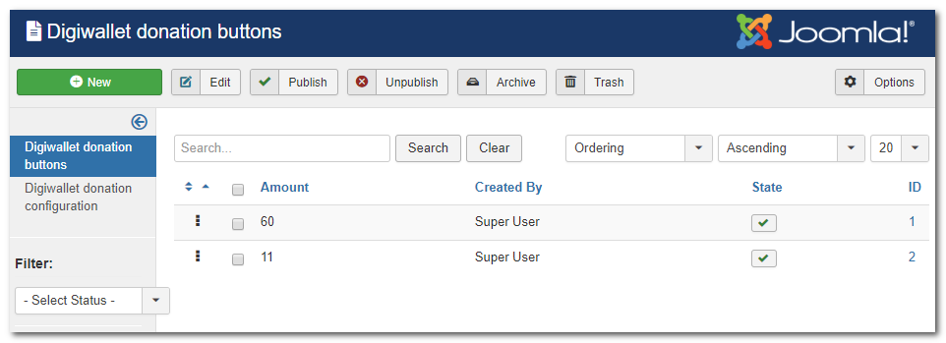

* Click New to add more button with Amount to pay.

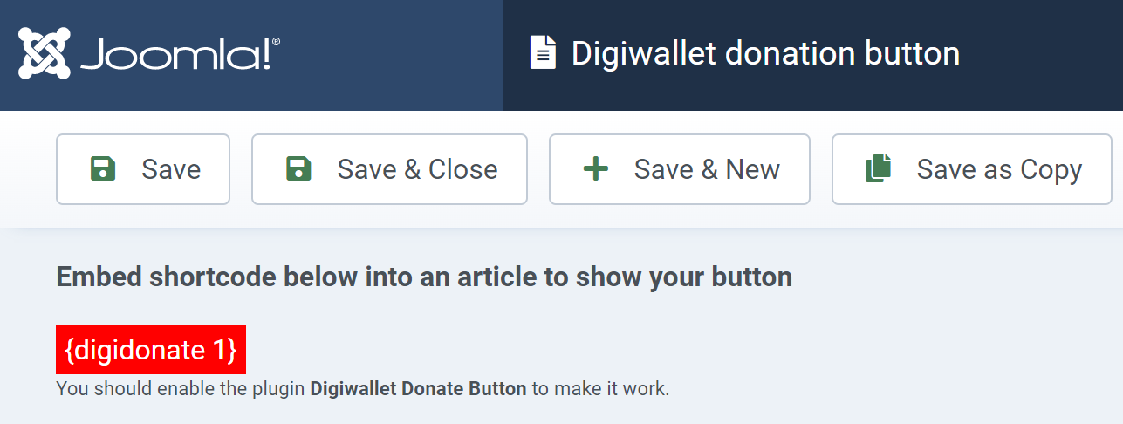

* Set State as Published to active this button.
* Copy the embed code to add to Article

# Using

Its easy to add donation buttons to your article, just by copying and pasting Embed code to Article’s editor

